IN605 Databases 2

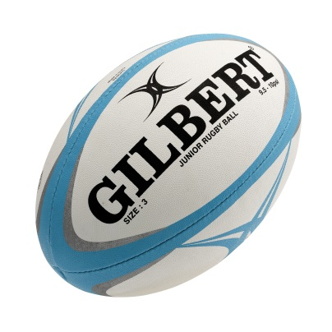

Data Model Assignment

Prepared for
Krissi Wood & Tom Clark

Prepared by
Adam Charlton

Otago Polytechnic
8 May 2013
Main Objective

The main objective this database, is to handle the registration & re- registration of players. An example of this, the input of new players and obtain information the Rugby Union confirms. Some of the main aspects that are required for this database:
Access the assignment of teams, registration forms, player contact details and track gear. This can cover a large set of information, the gear could include a coaches track suit and a gear bag that holds several items such as a first aid kit, training cones, bibs and balls. Also a record of the keys for the ground will be recorded and an associated list of restricted persons allowed access to the keys.
The teams play a different style of game which is based on the age of the players and will be recorded for the staff. A shop roster will also be recorded, stating which team is manning the shop, this is based on which team has home games.
The database will be able to link all the children to their parents for contact reasons and to resolve the issue of sending multiple forms and details to the same family.
The system will be able to record the team game scores and season results. It will also track awards that the teams receive, such as the end of season Most Valuable Player and Most Improved Player. The player of the day for each game will be recorded.
Some aspects noted are not in the scope of this database. This is the tracking of the store inventory, it is far too complex. This can be done separately then coupled with this database at a later date.
The information that the user will be able to obtain from the Database once it is finished is the writing of the weekly newsletter, mail merges, games information to be published to the website and the ability to generate reports for the end of season and staffing purposes.

Use Cases

Player Registration
- 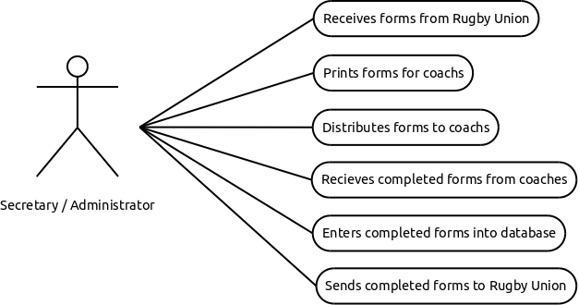

Send Information
- 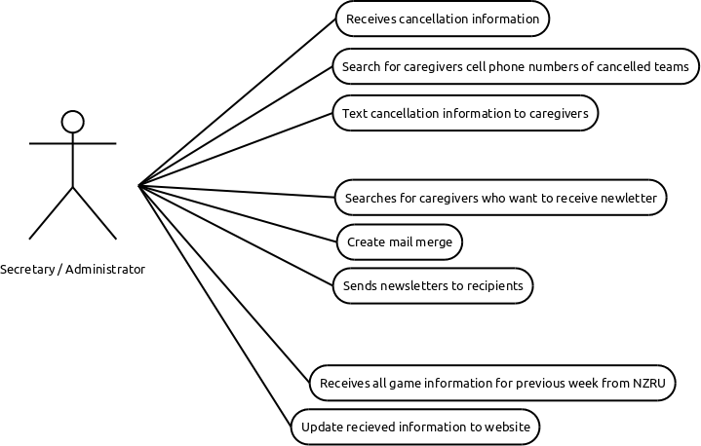

Tracking gear
- 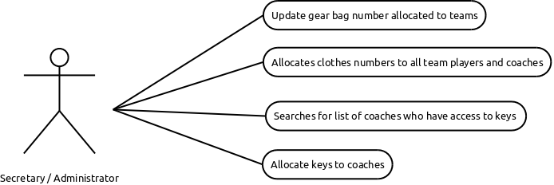

Shop Roster

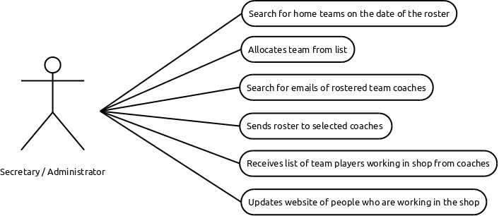Tracking Scores
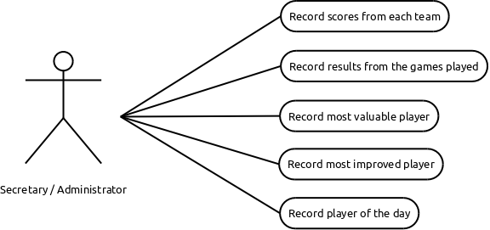

Data Model

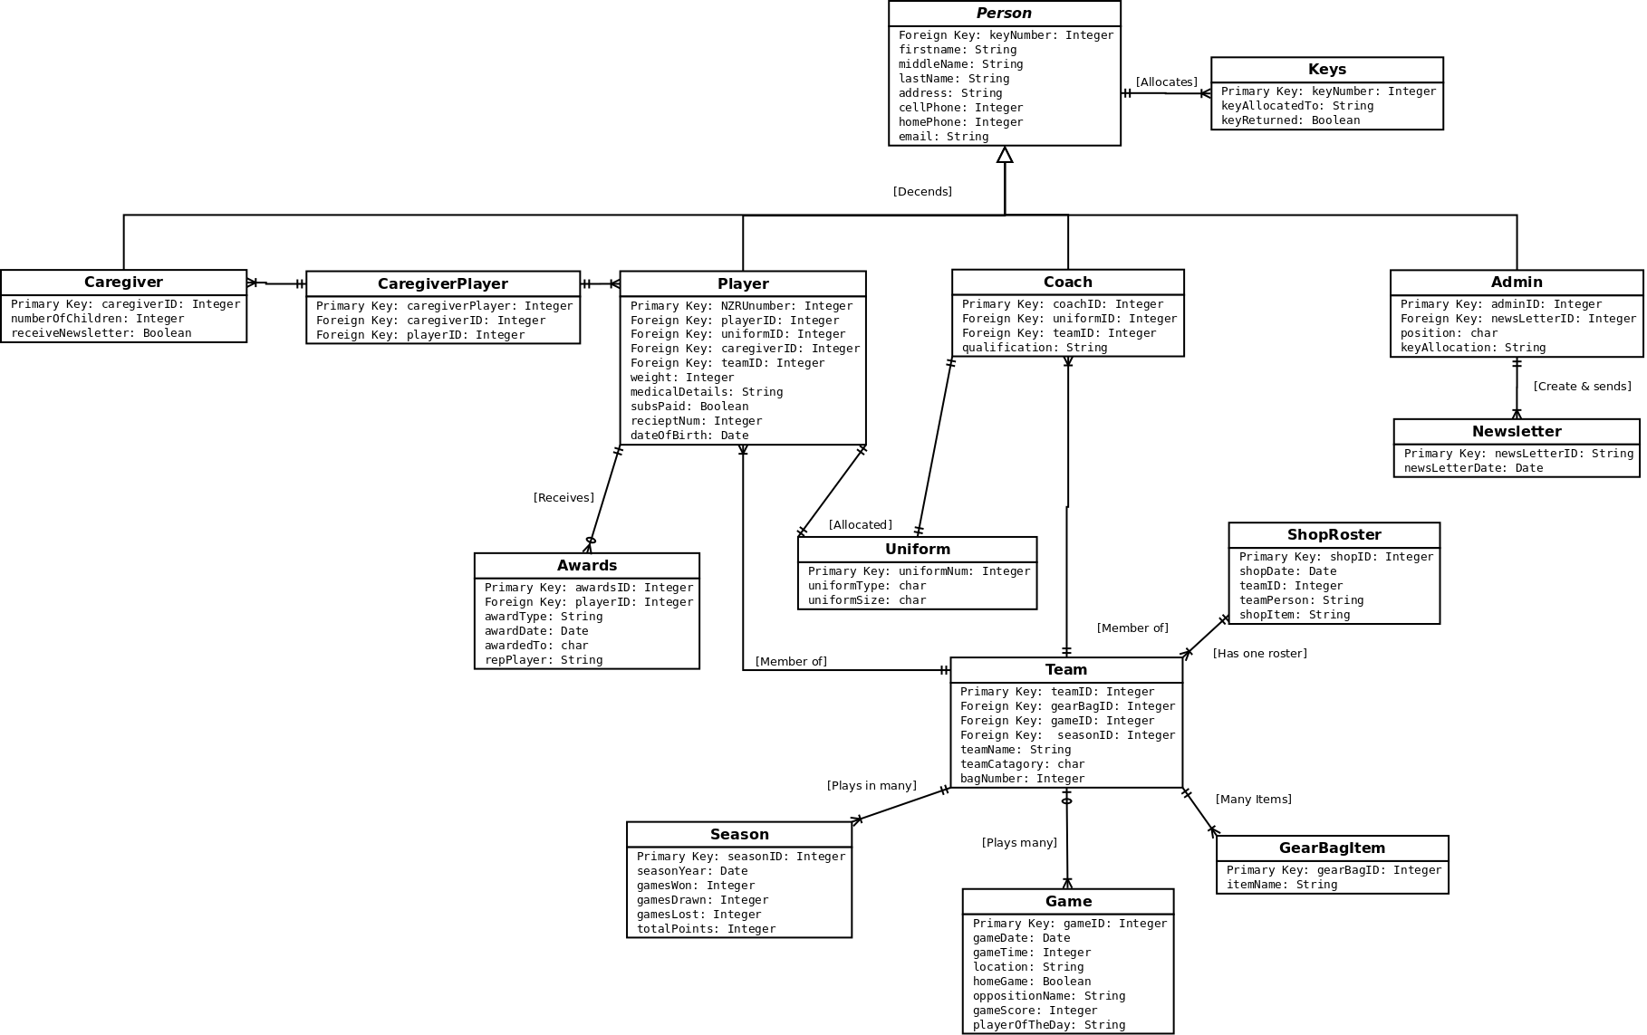

Data Dictionary
Table | Attribute | Data Type | Description
Person |  |  | Abstract Class
 | firstName  middleName  lastName  address  cellPhone  homePhoneNum  email | String  String  String  String  Integer  Integer  String | First Name  Middle Name  Last Name  Address  Cell number  Home number  Email address
Coach
 | coachID  uniformID  teamID  qualification | Integer  Integer  Integer  String | Primary key  Foreign key  Foreign key  Qualification of the coach
Player
 | NZRUNumber  playerID  uniformID  caregiverID  teamID  weight  medicalDetails  subsPaid  receiptNum  dateOfBirth | Integer  Integer  Integer  Integer  Integer  Integer  String  Boolean  Integer  Date | Primary key  Foreign key  Foreign key  Foreign key  Foreign key  Weight of player  Medical details of player  Has the subs been played  Receipt for players sub  Date of birth
Admin
 | adminID  newsLetterID  position  keyAllocated | Integer  Integer  char  String | Primary key  Foreign key  Staff position e.g. “Secretary”, “Treasurer”  Allocated person
Caregiver
 | caregiverID  numberOfChildren  receiveNewsLetter | Integer  Integer  Boolean | Primary key  Number of children that are players  Would like to receive a newsletter
Table | Attribute | Data Type | Description
CaregiverPlayer
 | caregiverPlayerID  caregiverID  playerID | Integer  Integer  Integer | Primary key  Foreign key  Foreign key
Season
 | seasonYear\  gamesWon  gamesDrawn  gamesLost  totalPoints | Date  Integer  Integer  Integer  Integer | Primary key  How many games won  How many games drawn  How many games lost  Total points over the season
Game
 | gameID  gameDate  gameTime  location  homeGame  oppositionName  gameScore  playerOfTheDay | Integer  Date  Integer  String  Boolean  String  Integer  String | Primary key  Date of game  Time of game  Location of game  Is game HOME | AWAY  Opposition team name  Score of game  Who got player of the day
ShopRoster
 | shopID  shopDate  teamName  teamPerson  shopItem | Integer  Date  String  String  String | Primary key  Date shop open  Team allocated to shop  Person in team allocated to shop  Items in the shop
GearBag
 | gearBagID  itemName | Integer  String | Primary key  Gear bag item name

Table | Attribute | Data Type | Description
Awards
 | awardsID  awardType  awardDate  awardedTo  repPlayer | Integer  StringDate  char  String  String | Primary key  Award presented (e.g. MVP, MIP, REP)  Date award presented  Person who received award  Represented local or regional teams
Newsletter
 | newsletterID  newsletterName  newsLetterDate | Integer  String  Date | Primary key  Name of newsletter, eg April Newsletter  Date of newsletter
Uniform
 | uniformNum  uniformType  uniformSize | Integer  Char  Char | Primary key  Clothes issued  Player size issued
Keys
 | keyNumber  keyAllocatedTo  keyReturned | Integer  String  Boolean | Primary key  Name of person key is allocated to  Record if returned at end of season

